# Module 6-1 Coding Assignment: Modifying Vulnerability Reporting

Joshua Williamson

10/10/2025

CS-305-10339

­

**Before:**

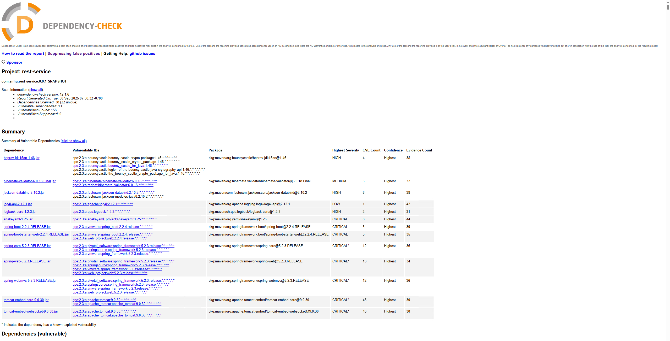

**After:**

